Document Information
Prepared For: | Atlas of Living Australia  Administrators and developers off the Atlas Field Data Capture Software

Publication History
Edition | Date
FINAL | March 2012

Google Maps API Key: Not Displaying
This issue occurs on new FieldData/BDRS portals where implementation has not been completed.

Issue:
Survey Maps will not load
Error message
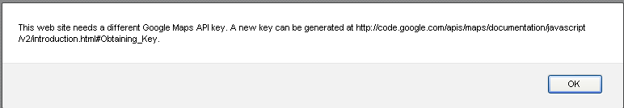

Fix:
Navigate to Admin > Manage Portal > Edit Preferences
Click Add API Keys Reference
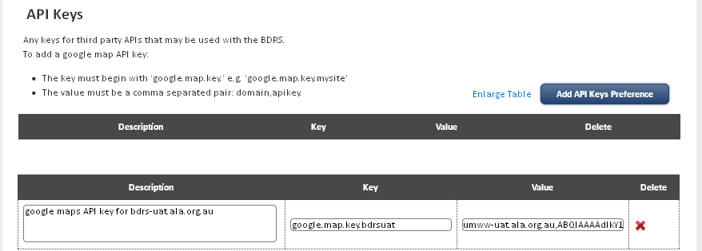
Add the following:
Description | google maps API key for bdrs-uat.ala.org.au
Key | google.map.key.bdrsuat
Value | umww-uat.ala.org.au,ABQIAAAAdIkY1hdL06bwR3W3WGL2lBTywzZ2Wb6D2-BxLGvg54t676eSkhTikAURtyN02ZrDmslYq8cI7Q4kUA
Notes
The same key is used on production and User Acceptance Testing servers.
Description and prefix to value can be anything - the real key is the value ala.org.au,ABQIAAAAdIkY1hdL06bwR3W3WGL2lBTywzZ2Wb6D2-BxLGvg54t676eSkhTikAURtyN02ZrDmslYq8cI7Q4kUA
This value makes the maps behave correctly
Save the preference
Test the map

