BDRS SURVEY – MANUALLY CODED MODERATION

Administration & Implementation

Introduction
The first part of this document describes the simple moderation process that can be added by a trained administrator to any survey in an instance of the Biological Data Recording System (BDRS)
The process of modifying a survey to support moderation is described in the second part of the document

Requirements
Administrators
Administrators should understand the relationship between species profiles and the lists of species that a user can select from in a taxonomic survey.
The relationship is explained in this document.
System
The BDRS taxonomy must include Uncertain, Unidentified and Not-Listed (or the administrators preferred equivalents) as species types that a user can select in a taxonomic survey.
This document shows how these options can be selected and what the moderator is able to do with these choices to achieve the desired outcomes.

Document Information
Prepared For: | Atlas of Living Australia  Administrators and developers off the Atlas Field Data Capture Software

Publication History
Edition | Date
FINAL | 20 March 2012

Summary of the moderation process:
Moderator reviews an uncertain/unidentified or not listed sighting
If the species can be positively identified then it can be assigned to the correct species in the field guide.
If there is no field guide entry then the Moderator creates a species profile and correctly assigns the record.
If the identification cannot be positively confirmed then the record should be assigned to Uncertain/Unidentified rather than not listed.
In each case the moderator comments to explain the basis of their decisions.

Simple flow diagram.

PART 1: USER LOGS A SIGHTING

workflow:
- Open the provided link to the website.
- Click on the Sign In menu item
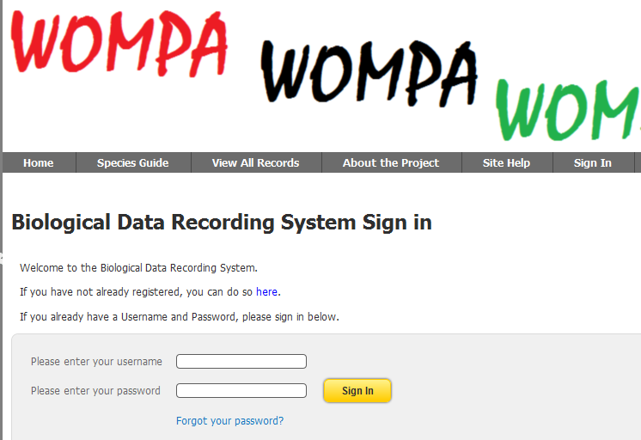
- Select Add a Sighting on the menu and choose Simple Sighting
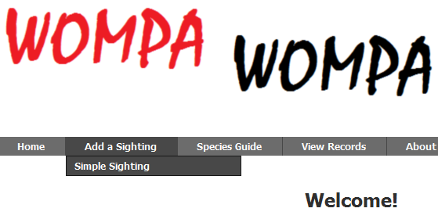
- The simple sighting form is displayed.
For the purposes of this moderation document we will step over the General Survey Information and Latitude and Longitude sections to the
- Species Observation Record section
You will notice there are instructions for the user on the screen.
They state that if the user does not know, or is uncertain, of the species they are logging then they should type Unidentified into the Species auto-complete field
If they believe they can identify the species but cannot find it in the Field Guide (note: there is a link that opens the field guide in a new tab window providing access from the survey) then they should type Not Listed
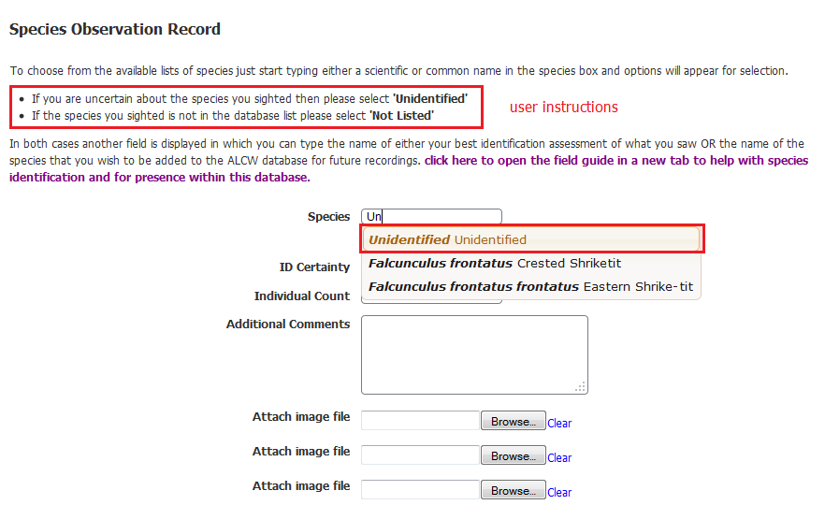

- When a user types and selects either Unidentified or Not Listed then a new field is displayed labelled “possible species identification”
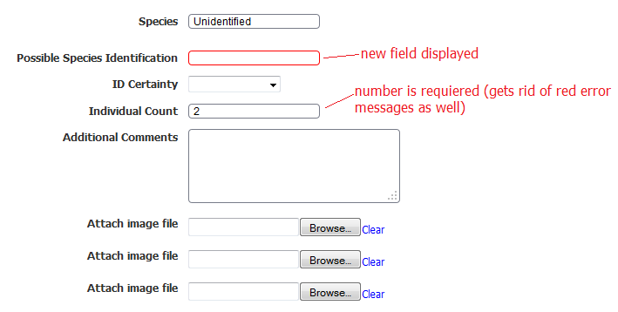
- The user should then type in their identification – either possible or actual if they are requesting a new species profile be added to the list.
There are several ways in which these options as presented could be interpreted by users:
  - If the user has not checked to see if there is a profile present for this species in the field guide then they may choose Unidentified or Not Listed
  - If the user has checked the field guide and they cannot find the species they may choose Unidentified (example below)
  - If the user has checked the field guide and they cannot find the species they may choose Not Listed (expected behaviour)
The interpretation of the term field guide used in these cases adds further complication – the user may have in fact browsed the actual field guide, or they may simply have typed a common name into the auto-complete field.
Both can be misleading – the BDRS present species with a known scientific name but only a single common name (unlike the Atlas of Living Australia) and so a species may in fact be present under a different common name or with a non-representative or too different image/s.
ALA BDRS V2 due March/April 2012 provides a search function across all and within taxonomy groups.
This will help substantially reduce the occasions where users miss listed species since the search engine searches across all species profile text including where the listed common name and potentially many other common names listed in the profile agrees with the users query.
- The user completes logging the sighting and saves the form.
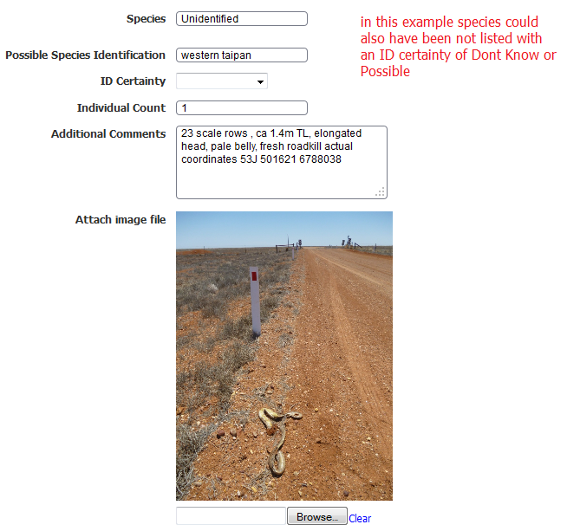
Example where ID appears positive but Unidentified has been selected

PART 2: THE MODERATION PROCESS
The basis of this simple moderation process is what each user can see and interact with on the survey page.
The bottom section of the survey page is different for a standard user
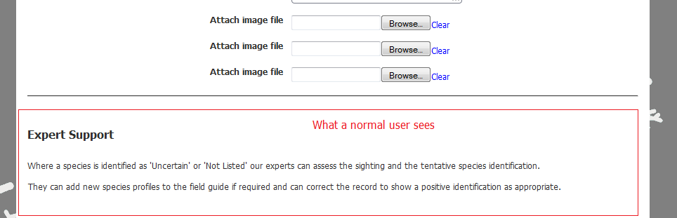
to what is presented to a moderator (who has the administrator role):
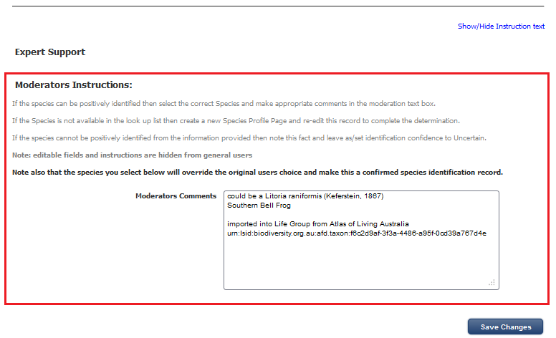
As you can see the moderator has their own comments field and instructions.

Moderation Steps
- Moderator selects an Unidentified/Uncertain or Not-Listed record from the list of records – View all records/My Sightings menu items.
- Moderator reviews User content.
- If the User has selected Not Listed the Moderator needs to confirm that the species is not listed in the Field guide.
  - The User will usually have offered a common name for the species in question.
  - The species may be listed in the Field Guide but under a different common name than the user is offering as the BDRS currently only supports a single common name for each species.
  - If this is the case, and the identification is confirmed, then the Moderator changes the species selection to the name of the positively identified species, makes appropriate comments and resubmits the record and informs the user.
  - If the species is not present in the Field Guide then the Moderator needs to create a species profile page which can then be subsequently used to complete this record.
- Where a positive identification cannot be made the Moderator makes appropriate comments and leaves species selection as Uncertain/Unidentified and informs the user.
Informs the user
This step is optional.
Manual Process: moderators have access to the Admin Manage People / Manage Users process and can access the users email address as well as send emails.
If the built in BDRS moderation process has been enabled then ALL records of all types are managed by a single threshold process – and usually held until moderated and released; which is why we have a implemented this simple coded option.
Automated Process:
It is possible to automate some BDRS processes using Thresholds that send emails when a record with a common name ‘Not listed’ is created and updated.
Emails are sent to all administrators in the database.

Adding Simple Moderation Code to a Survey

Introduction
The BDRS requires the presence of Taxon profile or Species pages for every species that is to be recorded in a taxonomic survey.
While this may be feasible for small or controlled numbers of groups and species it may be impractical for larger groups such as plants and insects, or where the preference is for the BDRS to evolve based on users sightings.
In this case users need to be offered a ‘Not Listed’ option to choose from which in turn can trigger administrators & moderators to respond appropriately – this could be to correct a misidentification or to add a species page for the observer organisms.
Similarly users may be unable to identify, or be uncertain of, their species identification and so may need to be offered choices such as ‘Unidentified’ and/or ‘Uncertain’

Built in Moderation
In V1.1 a new ‘built in’ moderation functionality was implemented which included some fixed rules about processing using survey form attributes and Thresholds.
By default the base model marks a new sighting as ‘Held’ and sends an email to every administrator and supervisor in the database.
A held record is only visible to its creator and all users with administrator and supervisor roles.
This emailing action happens each and every time a record is edited/updated until it is released into the public domain (or at least from its held status).
The Threshold (agent/script) sets the conditions that apply – default conditions are: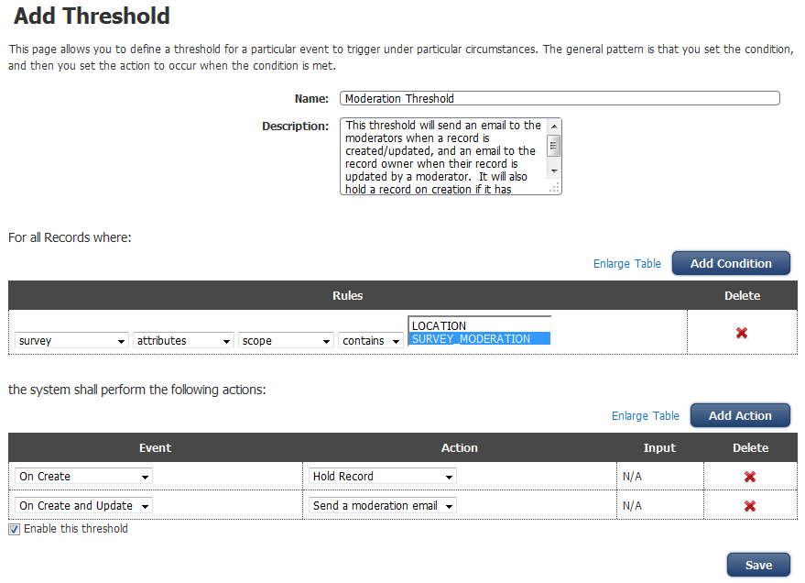
A number of groups consider this approach to be too restrictive and have asked for a more open mode.
Earlier development work prior to the moderation capability was based around assessing species identification supported with moderators assessment comments.
This approach has been enhanced to include controls of what is displayed and when in order to improve overall usability as well as meet moderation requirements.
This section describes a relatively simple moderation process that can be added by a trained administrator to any survey in an instance of the Biological Data Recording System (BDRS)
The basis of this simple moderation process is what each user can see and interact with on the survey page.

REQUIREMENTS: BDRS TAXONOMY
The code provided supports additional species called ‘Not Identified’, ‘Unidentified’ and ‘Uncertain’
A species page must be created for each.
They are usually assigned to the ‘Life’ taxon group as this is hidden from the species guide in most BDRS instances.
The survey taxonomy must be set to allow these ‘species’ names to chosen from the species auto-complete list.
See the BDRS Managing Themes 2012 Manual for instructions on creating and theming taxonomy pages at all levels.

REQUIREMENTS: SURVEY

Moderations Fields
- A moderation comments field is added to the survey:
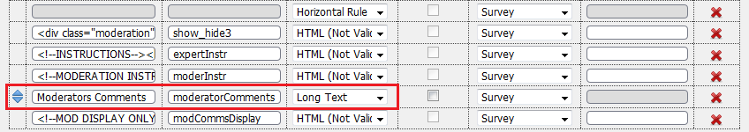
Standardisation is a desirable objective so please use the top example in this table if you haven’t already added a moderators comments field to your surveys.
Description of form | Name in the Database | Field Type
Moderators Comments | moderatorComments | Long Text
Other examples in use
Moderators Comments | REVIEWERCOM | Long Text
Note
On 20 March 2012 we agreed to create a new Field Type – moderator comments, which, once implemented, can be selected for your existing and new moderation comments fields. This approach preserves historical comments data while allowing moderation comments to be written into the planned “Add Comment to Survey” functionality in V2.0 as part of a records audit trail. When someone edits a record and saves it the name, time & date, and contents of the moderator comments field type field/s will be written into a new record comment.
- Additional fields
Expert and Moderation instructions HTML fields are added containing headings and help text.
<!--INSTRUCTIONS-->
<h3 >Expert Support</h3>
<div class="new"> - displayed on NEW sighting forms only
<div class="instructions"> display can be toggled using the ‘show/hide instruction text’ link
<div style="color: #808080;"><p>Where a species is identification is 'Uncertain' our experts can assess the sighting and the tentative species identification.</p><p>Where the species is identified as 'Not Listed' they can add new species profiles to the field guide make future sightings easier to log.</p><p> In both cases they can correct the record to show a positive identification as appropriate.</p></div>
</div>
</div>

<!--MODERATION INSTRUCTIONS-->
<div class="instructions" > display can be toggled using the ‘show/hide instruction text’ link
<div class="moderation"> only displayed to moderators
<h3>Moderators Instructions: </h3>
<font color="#808080"><p>If the species can be positively identified then select the correct Species and make appropriate comments in the moderation text box.</p><p>If the Species is not available in the look up list then create a new Species Profile Page and re-edit this record to complete the determination.</p><p>If the species cannot be positively identified from the information provided then note this fact and leave as/set identification confidence to Uncertain.</p><p style="color: blue; font-weight:bold">Note: editable fields and instructions are hidden from general users</p></font><p><strong>Note also that the species you select below will override the original users choice and make this a confirmed species identification record.</strong></p>
</div>
</div>
- A modCommsDisplay field is added – this field displays moderator comments to general users when they are editing their own records.
<!--MOD DISPLAY ONLY-->
<div id="modcommslabel" style="color: #808080; text-align: right; font-weight: bold;width: 39%;float:left;"><strong>THE LABEL IS ONLY WRITTEN IN HERE IF THERE IS CONTENT IN THE moderatorComments FIELD</strong>
</div>
<div id="modcommstext" style="color: #808080; text-align: left; width: 60%;float:right; ">CONTENT IS WRITTEN HERE FROM THE moderatorComments FIELD IF AVAILABLE</div>
<div style="clear: both;">

- A new field is added to the survey form called something like ‘Species to be added’ or ‘Possible Species Identification’
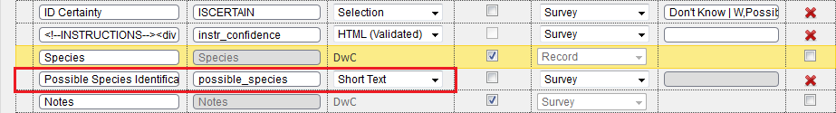
This field will not be displayed unless the user chooses ‘Not Identified’, ‘Unidentified’ or ‘Uncertain’
When they do this field and its label are advising them to identify either the species page to be added to the system or their tentative species identification – you can choose either, both or some other emphasis for your BDRS.
Before selection:
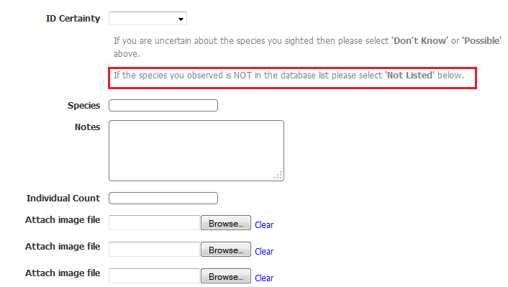
Selecting:
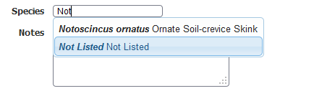
After selection:
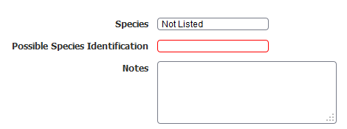
At this stage – in a new sighting – the user can see some comments at the foot of the page about Expert Support.
For simplicities sake they are always displayed (not just when a user makes one of the selections above)
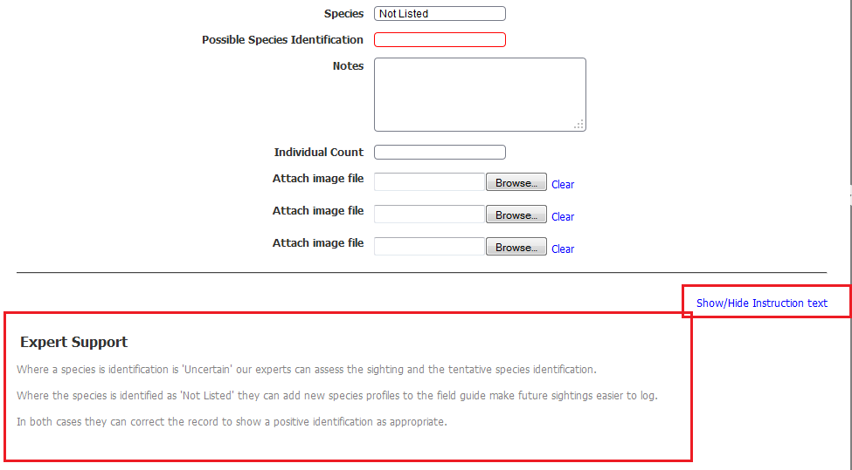
Note also the show/hide instruction text link: code below
When the sighting is saved all Moderators are advised of new data requiring attention.
The bottom section of the survey page is different for a standard user
Compared with what a moderator (who has the administrator role) can see:
Moderators can see their own comments field and instructions. Comments they make are visible to all allowed readers of the sighting record.
The moderation process is described in more detail in the document Simple Survey Moderation March 2012 found in the reference materials section here - http://www.ala.org.au/get-involved/citizen-science/fielddata-software/fielddata-training-materials/
- A new field called pageMode of type HTML (not Validated) is added to the head of the survey
pageMode contains reasonably complex javascript code that:
- Identifies the current page mode – whether this is a new sighting, or an existing record in read or in edit mode
- Conditionally sets default display values for fields on the form including
  - Add/request species fields
  - Moderation comments fields
  - Instructions display settings – show when new or in edit, hide when in read mode (not needed)
Code attached as text field here:
Text file containing the code can also be found here - http://www.ala.org.au/get-involved/citizen-science/fielddata-software/fielddata-training-materials/
This is the most complex part of the process for the following reasons.
When a field is added to the Survey form using the form field chooser amongst other things it gets an attribute number.
For example the Request add species/Possible species identification field added above.
On the Atlas of Life in the Coastal Wilderness User Acceptance Testing site the field has description ‘Species to be added’, name in database ‘add_species’ and is of type short text.
When you preview the survey form and inspect the element using a suitable tool (for e.g. firebug with Firefox) you will see this:
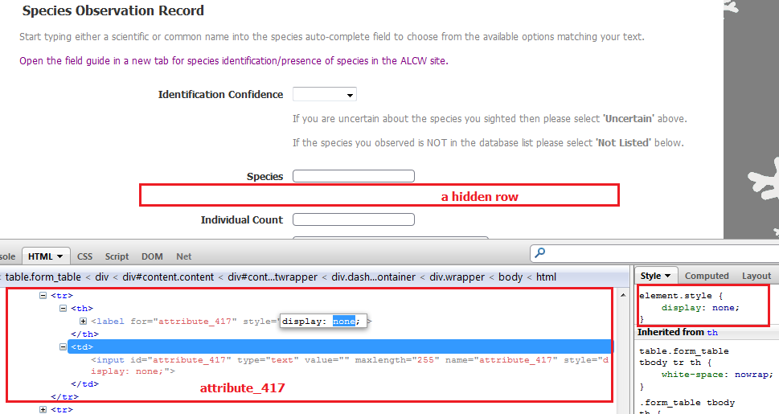
The same field added to the same survey on the Production server has a different attribute number of 372 – they are a function of the server, the BDRS instance, and a bunch of other things which make them UNIQUE for each instance.
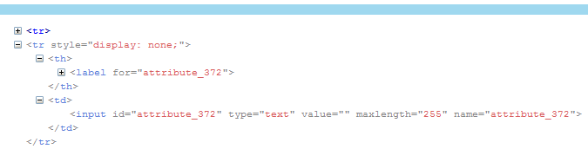
Each time you implement the moderation code in a new survey you will need to get the NEW attribute numbers for the two affected fields – add species and moderator comments – and search & replace the new attribute numbers within the provided code.
- Last - adding another field that operates with the standard Species auto-complete field to set/reset display for the possible ID/request species fields
<!--NOT LISTED AUTOCOMPLETE-->
<script type="text/javascript">
jQuery('#survey_species_search').focus(function() {
jQuery('#survey_species_search').autocomplete("option", "select", function (event, ui) { var taxon = ui.item.data;
jQuery("[name=species]").val(taxon.id).trigger("blur");
jQuery('#specialCommonName').html(taxon.commonName);
jQuery("[name^=taxonGroupAttr_]").parents("tr").remove();
if(taxon.commonName == 'Uncertain' || taxon.commonName == 'Not Listed') { $('#attribute_372').css("border","1px solid red"); $('#attribute_372').css("display",""); $('#addSpecies').css("display",""); $('[for=attribute_372]').css("font","red"); $('[for=attribute_372]').css("display","");
$('label[for="attribute_372"]').parents('tr').show(); } else {
$('label[for="attribute_372"]').parents('tr').hide();
$('#addSpecies').css("display","none"); $('[for=attribute_372]').css("font","red"); $('[for=attribute_372]').css("display","none"); }
var params = {};
params.surveyId = jQuery("[name=surveyId]").val();
params.taxonId = taxon.id;
var recordIdElem = jQuery("[name=recordId]");
if(recordIdElem.val().length > 0) {
params.recordId = recordIdElem.val(); }
jQuery.get("/bdrs-core/bdrs/user/ajaxTrackerTaxonAttributeTable.htm", params, function(data) jQuery(".form_table").find("tbody").append(data);
});
});
});
</script>
- Show/Hide Switcher Code
***********SHOW HIDE TEXT SWITCHER
Instructions
- create a new field on your survey form of type HTML with a name such as hide_text or hideInstructions
- copy the code below and paste into the HTML field
- you can add as many of these fields as you like
REQUIRED - FIRST COMPLETE FUNCTIONING FIELD
--------------COPY CODE START --------------
<div style="text-align: right; padding-top: 0.5em;"> <a id="hideShowtextLink" href="javascript:handleChange(this);">Show/Hide Instruction text</a>
</div>
<script type="text/javascript"> function handleChange(cb) {
if($('.instructions').css('display') == 'none'){
$('.instructions').show('slow');
} else { $('.instructions').hide('slow');
}
};
<script>
--------------COPY CODE FINISH --------------

STANDARD ADDITIONAL FIELDS
use the handleChange function created above
--------------COPY CODE START --------------
<div style="text-align: right; padding-top: 0.5em;">
<a id="hideShowtextLink" href="javascript:handleChange(this);">Show/Hide Instruction text</a>
</div>
-------------COPY CODE FINISH --------------

REQUIREMENTS: THRESHOLD
Finally – creating some Threshold actions which will send emails when moderation is required and performed.
In this image the default Moderation Threshold action is disabled and two new ones created: one for Not Listed and the other for Unidentified.
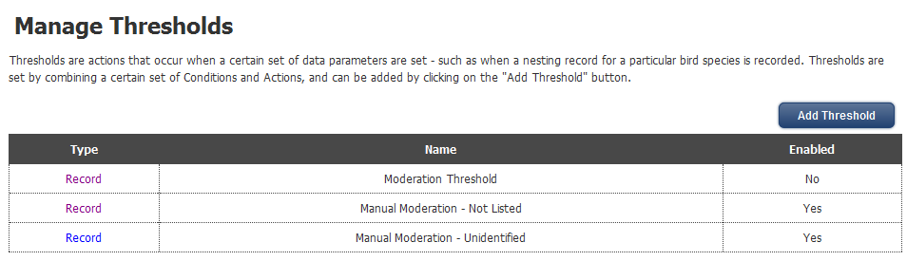
The rules are added by selection from pull down list options:
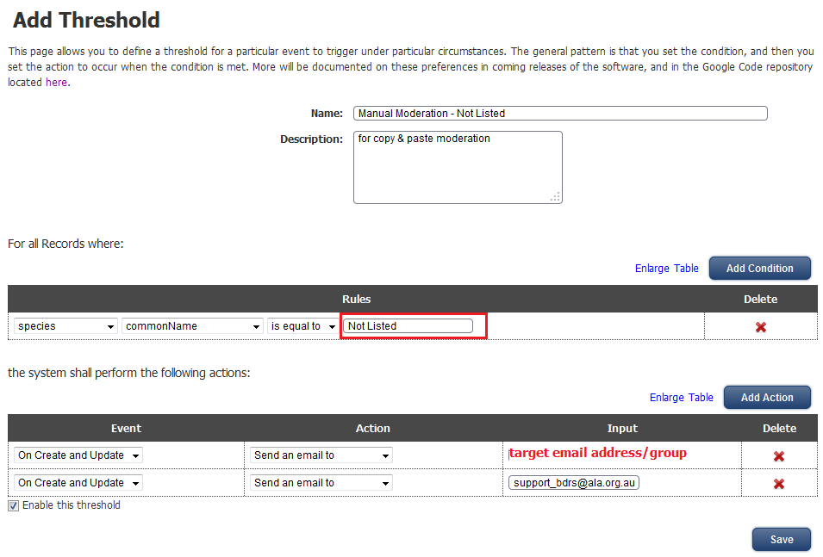
Note that the setting is for all Records – this is set on first creating the Threshold: it cannot be changed afterwards.
Separate actions thresholds are required for Not Listed and Unidentified as each condition added to the first table is an AND condition – and you aren’t going to get records where species = Not Listed AND Unidentified.

TESTING
One the fields have all been added and code modified to reflect changed field attributes (and on screen text enclosed in <div class=instructions”> </div> ) thoroughly test the form.

Expected behaviours:
New sighting
- all instructions displayed
- expert heading and help displayed
- add new species label and field (whole row) default hidden
  - displayed when user selects Not Listed. Uncertain or Unidentified in species auto-complete: and hides again if they change their minds.
- moderation instructions heading, instructions and field content hidden
Read existing Record
- all instructions hidden
- expert heading displayed but expert help hidden – for new surveys only
- add new species label and field (whole row) displayed when user selected Not Listed. Uncertain or Unidentified: hidden if they have selected anything else.
- moderation instructions heading and help hidden
- moderation label and comments displayed
Edit existing Record
- all instructions displayed
- expert heading displayed but expert help hidden – for new surveys only
- add new species label and field (whole row) displayed when user selected Not Listed. Uncertain or Unidentified: hidden if they have selected anything else.
- moderation instructions heading displayed
- moderation label and comments displayed - editable if an administrator

List of additions to survey:
- Species pages for ‘Not Listed’, ‘Uncertain’, ‘Unidentified’ added to Taxonomy Life Group
- Moderators
  - Expert help HTML text field
  - Instructions HTML text field
  - comments field
  - comments display field
- ‘Species to be added’ or ‘Possible Species Identification’ field
- HTML field pageMode in header
- Species auto-complete extension code HTML field
- Threshold actions for ‘Not Listed’, ‘Uncertain’, ‘Unidentified’ species selection

