Birds I predict I will find in the school yard
Picture | Name | Tick the predicted place
 |  | Ground | Tree | Sky
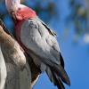 | Galah
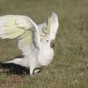 | Cockatoo

