Birds I saw in the schoolyard
Picture | Name (if known) | Number | Place seen
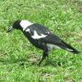 | Magpie

