Choose one of the birds from the list. Look at the images of the bird.
The bird I have chosen is ______________________
Circle the picture of bird feet that looks most like your bird.
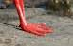
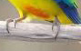
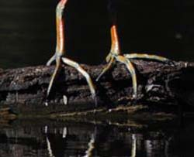
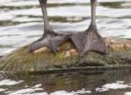

Circle the picture of bird beaks that looks most like your bird.
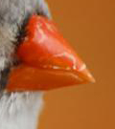
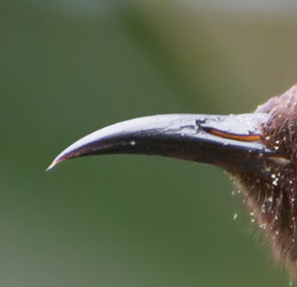
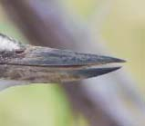
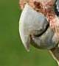

The thing I like most about my bird is ________________________________________________________________________________________________________________________________________________________________________________________________________

