4. Symbiotic relationships
Use the ALA to plot the distributions of two species; the Cassowary (Casuarius casuarius) and the Cassowary Plum (Cerbera floribunda). For instructions on how to do this, see ALA Teacher Guide 2 – Species distributions on a map.
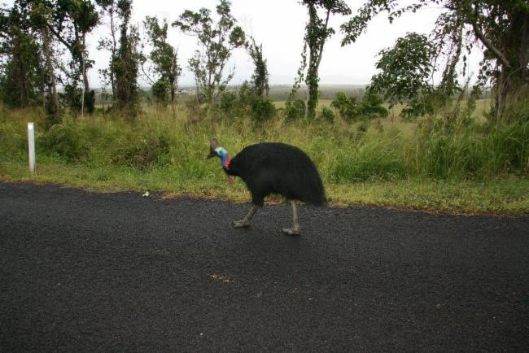

Image: Kenneth Foster – ALA Individual sightings

- The relationship between these species can be described as symbiotic. Explain what this term means in relation to these species.
- Find other examples of symbiotic relationships between species and plot their distributions on a map. Is their symbiotic relationship the same type as the one between the Cassowary and the Cassowary Plum?

