**Dichotomous keys**

1. Create a dichotomous key that classifies these eight species. These images are from the ALA.

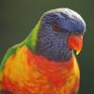

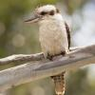

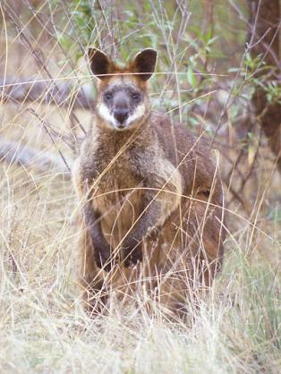

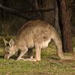

Eastern Grey Kangaroo

Rainbow Lorikeet

Kookaburra

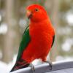

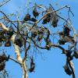

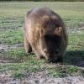

King Parrot

Wombat

Grey-headed Flying-fox

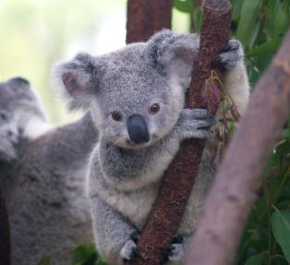

Swamp Wallaby

Koala

1. Use the ALA to find 8 animals that are found within 5km of your school. Construct a dichotomous key to classify them. Instructions on how to find species in your local area can be found at [www.ala.org.au](http://www.ala.org.au).