Your local area
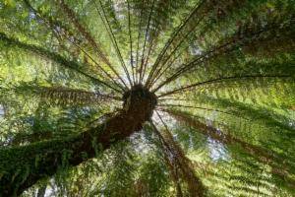

Dicksonia antarctica – Soft Tree Fern Source ALA Individual sightings

- List biotic and abiotic factors of the ecosystem that you are studying.

For the biotic factors, try and get pictures and identify any unknown species. For hints on how to identify unknown species, head to the Species identification page of the ALA.
- Of the biotic components, which are producers and which are consumers?

- List two ways that the abiotic and biotic components interact in this ecosystem.

- Using both the biotic and abiotic factors, find examples of:
Commensalism, parasitism, and mutualism.
(You may have difficulty doing this based only on what you observed. Using the ALA, see what has been recorded in that area to complete the above. For instructions on how to do this, see ALA Teacher Guide 1 – Finding the species recorded in your area.)

