Case studies – Slopes to Summit (S2S) – provided by Sam Niedra (Nature Conservation Trust)
Thurgoona BioBlitz (May 2012)
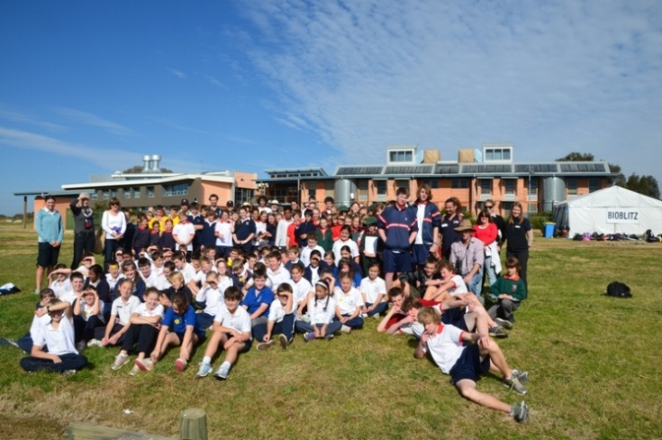
The Thurgoona BioBlitz was held over two days and one night at Thurgoona NSW, on the outskirts of Albury, and engaged around 300 school students, Landcare members, and other local residents. The event involved 36 wildlife surveys at a number of urban and rural sites targeting birds, reptiles, amphibians, mammals, and invertebrates. The surveys were led by ecologists, many of whom were from S2S partner organisations including Australian National University and Charles Sturt University. Over 100 fauna species were recorded, including Brown Falcon, Sloane’s Froglet, and Squirrel Glider. The data collected has been uploaded into the Atlas of Living Australia via a site developed by the Atlas in collaboration with the S2S partnership (http://s2s.ala.org.au). The event was partnered by the Woolshed Thurgoona Landcare Group a funded by the Federal Government’s Caring for Our Country ‘Community Action Grants’ program, the NSW and funded by the NSW Government’s Environmental Trust, Atlas of Living Australia, Albury Conservation Company, and CSU Green. For photos visit https://www.flickr.com/photos/great_eastern_ranges_initiative/sets/72157637366985825

Woomargama BioBlitz (Sept 2013)
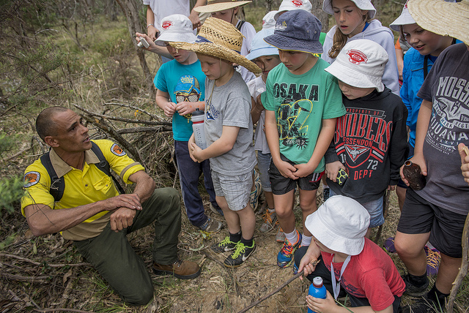
The Woomargama BioBlitz was held over three days and two nights at Woomargama NSW, between Albury and Holbrook, and engaged around 280 people, including students from seven local schools. The event involved over 30 wildlife surveys across different land tenures including public reserves (e.g. Woomargama National Park, Benambra National Park), travelling stock reserves, and farms (e.g. Woomargama Station). The surveys targeted birds, reptiles, amphibians, mammals, and plants, and were led by 17 ecologists, many of whom were from partner organisations including Australian National University and Charles Sturt University. Over 111 fauna species were recorded, including Squirrel Glider and Southern Pygmy Perch. The data collected has been uploaded into the Atlas of Australia via a site developed by the Atlas in collaboration with the S2S partnership (http://s2s.ala.org.au). The event incorporated a traditional Wiradjuri Welcome to Country and smoking ceremony to launch the event during the school’s day, a Nature Photography Workshop hosted by Esther Beaton, and the use of motion sensing cameras set up in the national parks two weeks prior to the event. Key partners included Woomargama National Park Volunteers, Woomargama Hall Committee, and the local Rural Fire Service for providing base facilities and event catering. The event was funded by the NSW Government’s Environmental Trust. For photos visit https://www.flickr.com/photos/great_eastern_ranges_initiative/sets/72157636783704343

