Dichotomous keys
A dichotomous key consists of a series of statements that describe something’s characteristics. Each step presents two choices. Making the choice about each characteristic leads to a new branch of the key, eventually leading to the thing you’re trying to identify. A simple one is shown below.
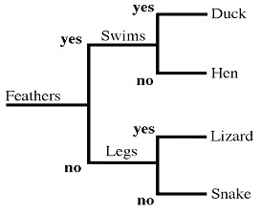

- Create a dichotomous key that classifies these eight species. These images are from the Atlas of Living Australia.
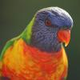
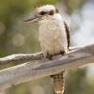
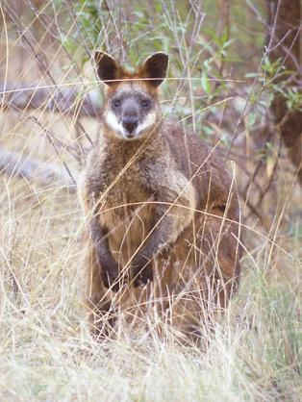
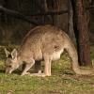

Eastern Grey Kangaroo
Rainbow Lorikeet
Kookaburra
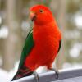
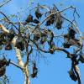
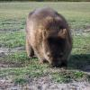

King Parrot
Wombat
Grey-headed Flying-fox
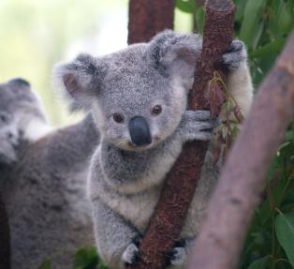
Swamp Wallaby

Koala

Draw your dichotomous key below.

- Use the ALA to find 8 animals that are found within 5km of your school. Construct a dichotomous key to classify them. Instructions on how to find species in your local area can be found at www.ala.org.au.

