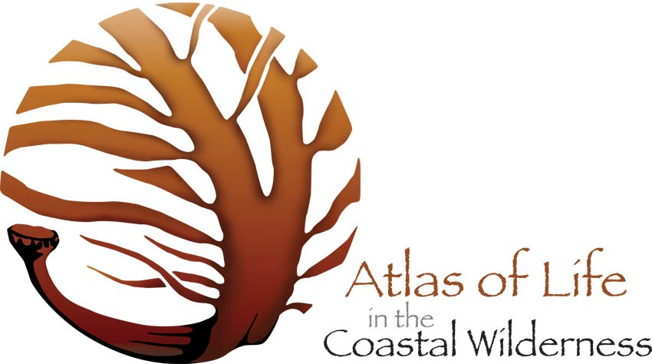

Address & Date

Dear Survey Leaders,

It’s that time again and we are getting ready to roll for the Four Winds BioBlitz.

Once again, many thanks for offering to lead the surveys which make BioBlitzes such meaningful events to be part of. Please let us know if we can help you in any way.

A number of people have volunteered to work with Survey Leaders as assistants on your surveys where you would like recorders, photographers, NatureMapr guides, or general helpers. You can pre-arrange this at the event, or ask participants if there are any Survey Leaders Assistants at the start of each survey.

General Information -

* For emergency calls or calls back to Basecamp the numbers are: ………………. or ………………. (BioBlitz coordinator), or 000 for ambulance / police. Please ensure you have these numbers with you at all times.
* We have food available for you at Basecamp during the event, so do come back and relax when you can.
* We will have a clipboard with your Survey Details and participant lists at Basecamp. If you can’t get back for this, we can send the information out with a survey participant.

Our BioBlitzes are all about giving the community the chance to walk and learn from the experts so we would ask that, as well as the health and safety briefing you will give at the beginning of each survey, you take time to talk about what you are hoping to find during the survey and to explain the methodologies you will be demonstrating. For your health and safety briefing, please refer to the risks you identified in the risk assessment you completed, and please bring a hard copy of this with you if helpful.

During this BioBlitz we are encouraging people to use our new [NatureMapr](http://atlasoflife.naturemapr.org/) recording platform. We can help people at Basecamp download the app to their smartphones or tablets, or they can take photos and record their sightings later. Please encourage your participants to take photos of as many species they find which are interesting - even if they can’t identify them - as we will have experts helping to identify species online and at Basecamp where there will be lots of reference materials and good internet connections to search online.

It is important that people take pictures of specimens from several angles to help with identification - for example with plants - several images of the flower from different angles, pictures of the leaves, and any seeds there might be. With ferns it is important to take pictures of the hairs on the underside of leaves and the stem.

We look forward very much to welcoming you to the BioBlitz and having lots of fun together over the next few days.

All good wishes,