2. Native species pests
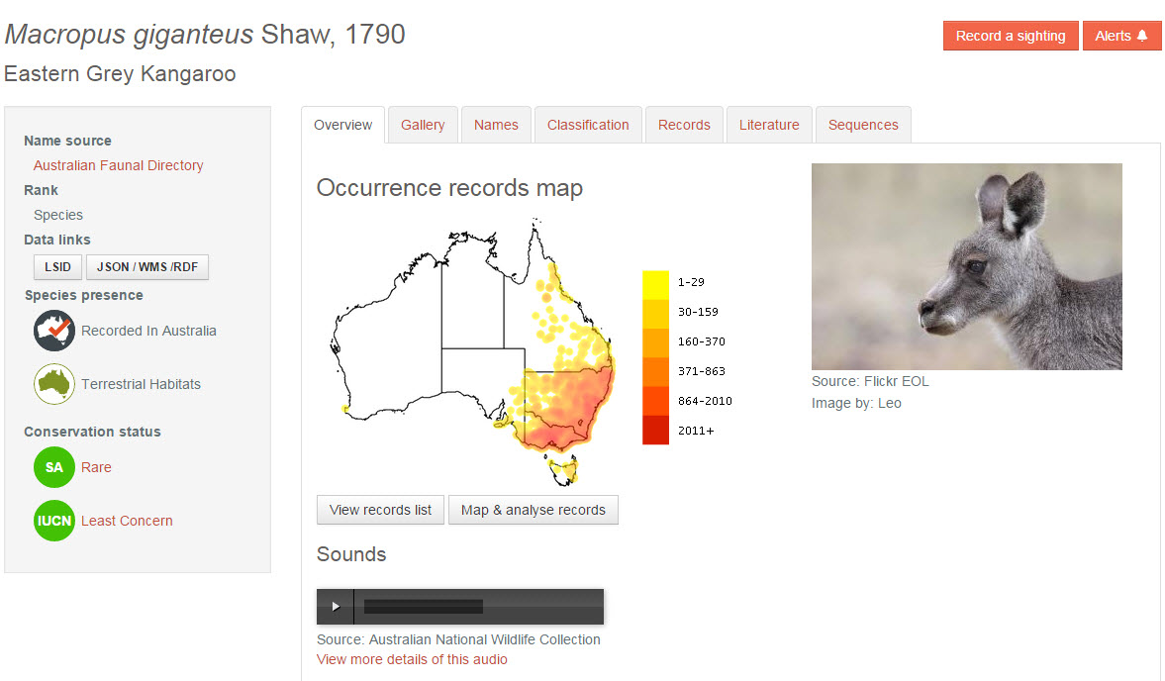

Use the ALA to find an example of a native animal species that has become a pest.
- Where does the species occur now? Use ALA maps to illustrate this. For instructions on how to do this, see ALA Teacher Guide 2 – Species distributions on a map
- What circumstances allowed it to become a pest?
- What is being done to control it?
- Outline possible consequences of leaving it uncontrolled
- Given its current range, where could it inhabit if left uncontrolled?
- What other species does it affect now? What potential species could it affect if left uncontrolled?
- If it is successfully controlled, what consequences could this have for the environment and other species?

