Classification
- Using the Atlas of Living Australia, find images of each of the birds below and copy them onto the page. The first few have been done for you.
Cockatiel, Sulphur-crested Cockatoo, Crested Pigeon, Common Pigeon, Galah, Australian Magpie, Willie Wagtail, Mudlark, Common Barn Owl, Australian White Ibis, Wedge-tailed Eagle
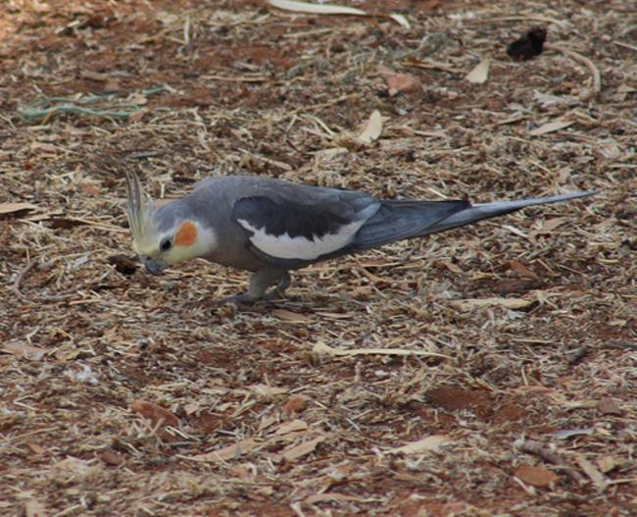
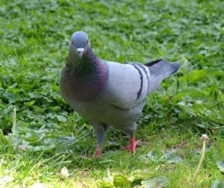
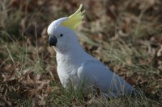

Sulphur-crested Cockatoo
Cockatiel
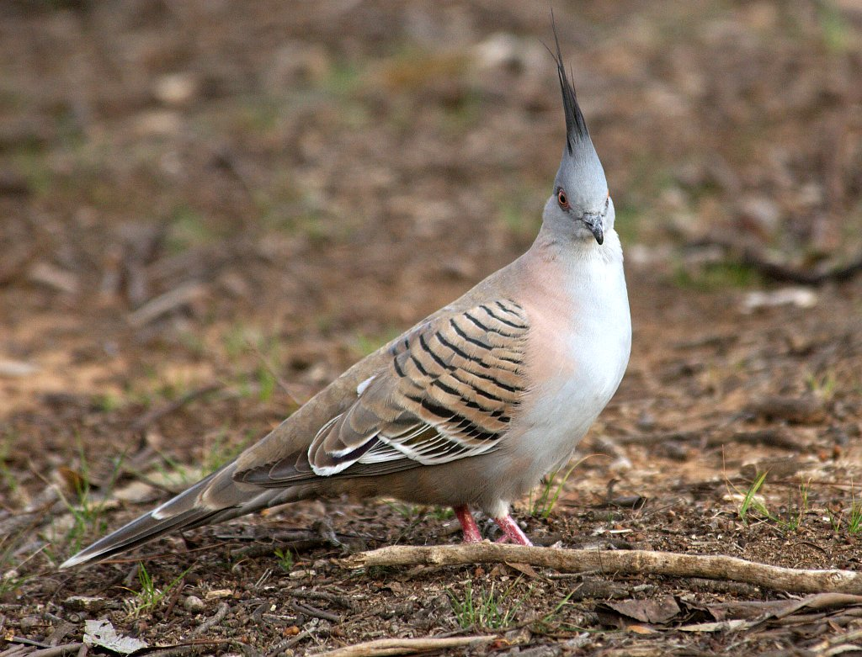
Common Pigeon

Crested Pigeon

- Organise all of these birds into three groups based on physical characteristics. Write a paragraph explaining why you grouped them the way you did. It may help to look at a number of different images of the birds to help with your description. You may need to read some information about the species.

__________________________________________________________________________________

__________________________________________________________________________________

__________________________________________________________________________________

__________________________________________________________________________________

__________________________________________________________________________________

__________________________________________________________________________________

_________________________________________________________________________________

- Of these birds, choose two that you think are the most similar and write the species name for them. Using the classification information from the ALA, determine the lowest classification level that the two birds you chose share.

