What’s in your local area?
On your field trip, record and identify the living things you find.
If you have trouble identifying a specimen, click here.
Record these sightings on the Atlas of Living Australia. For instructions on how to do this, see User Guide 4 – How to record a sighting.
Compare your group’s sightings in the area to those already logged on the ALA. An example is shown below.
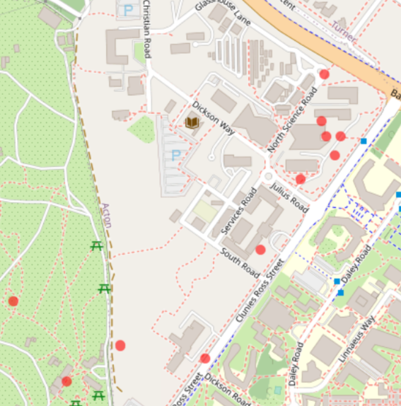

Sightings (shown as purple dots) of one person in an area
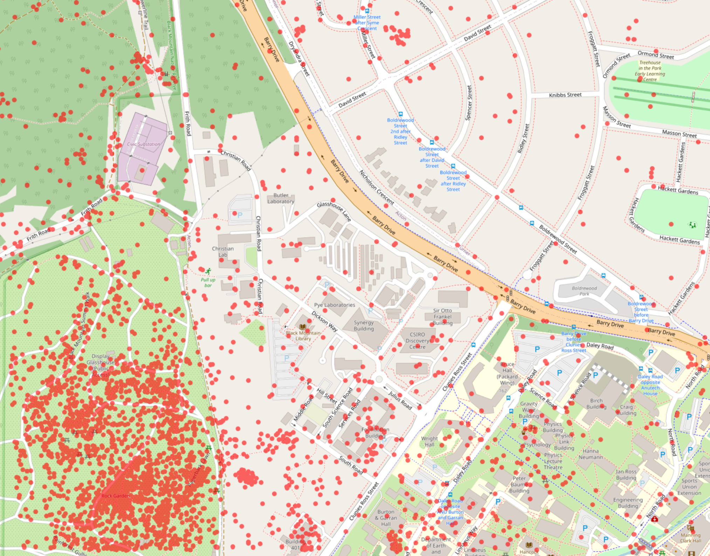

Whole set of sightings in the same area (shown as red dots)

Comment on the similarities and differences between your data and the whole data set.
Use the ALA to compare the differences between your area and another nearby one.

