Feeding relationships in your local area
Using the ALA, look at the species that are found in your local area. For instructions about how to do this, see User Guide 1 – Finding the species located in your area.
An example is shown below.
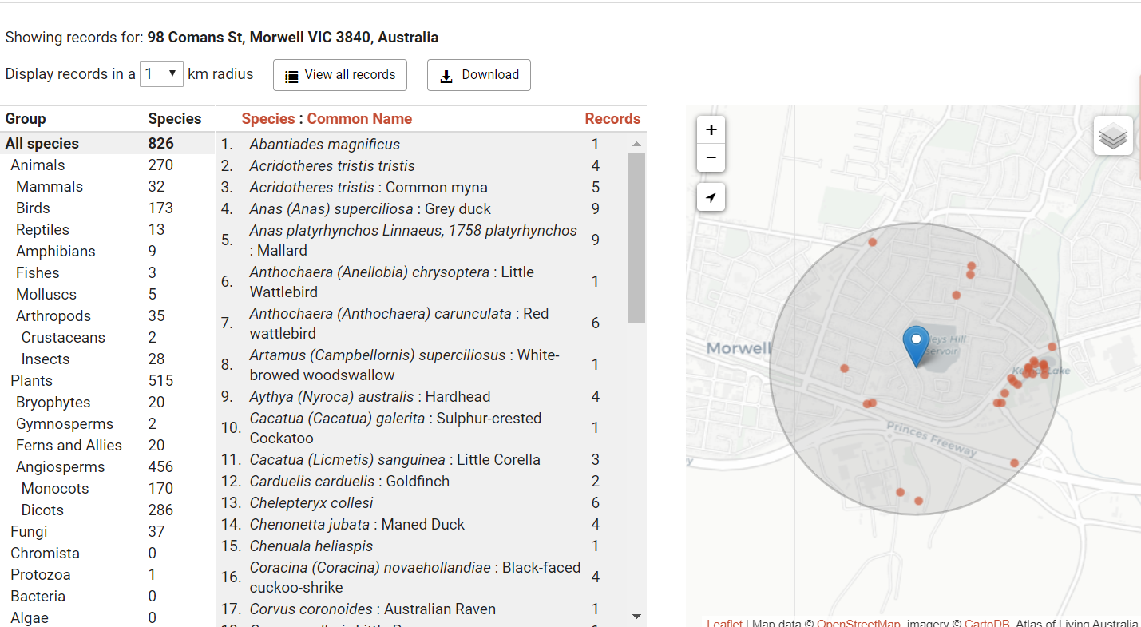

A map showing sightings in an urban area and a list of the species

From the species information on the ALA for your area, list 3 producers, 3 first order consumers and 3 second order consumers. You will need to consult the species pages (See User Guide 6 – Finding information about a species) and other sources to find these.
Complete the following food chain from the ALA species information in your area:
Producer First order consumer Second order consumer Third order consumer

Producer First order consumer Second order consumer Third order consumer

Are there any species on the list that could be both a first and a second order consumer?
Are there any species on the list that could be both a second and a third order consumer?

Complete a food web from the ALA species information in your area:

Is there anything missing from the species for your list that makes it difficult to complete your food web? Why might this be missing?

