Distribution maps of three species
- Mountain Pygmy Possum

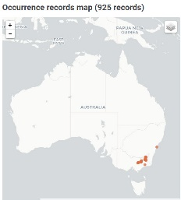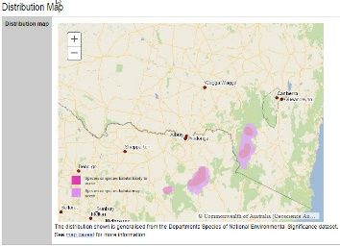
- Koala
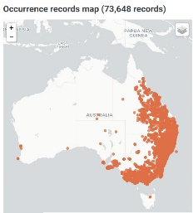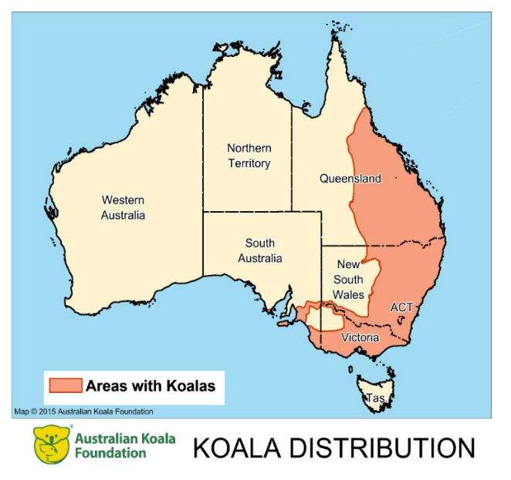

- Tasmanian Devil
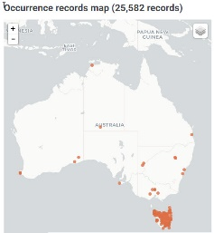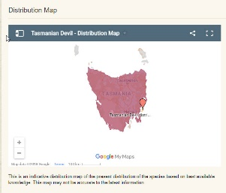

Consider the three pairs of distribution maps above. The map of the left is from the species page of the Atlas of Living Australia, and the one to the right is the same species from another source
- For each of the three pairs of maps, make a comment about how well they match each other.

- What is one reason that the maps from the ALA and the other source may not match each other?

- Use the ALA and another source to find two different distribution maps of the same species and comment on the similarities and differences found.

